Electromagnetic Simulation and S-Parameter Characterization of a Microwave Directional Coupler and Two-Way Power Divider
Aim:
To simulate a microwave directional coupler and two-way power divider and analyze their performance using S-parameters.
Procedure:
- Open MATLAB or suitable electromagnetic simulation software.
- Design the microwave directional coupler and two-way power divider by specifying their dimensions, operating frequency, and substrate properties.
- Simulate the structures and obtain the S-parameters (S11, S21, S31, and other relevant parameters).
- Plot the S-parameters over the selected frequency range and observe the reflection, transmission, coupling, and isolation characteristics.
- Compare the simulation results and evaluate the performance of both microwave components.
Code:
clc;
clear;
close all;
%% =========================================================
% ELECTROMAGNETIC SIMULATION AND S-PARAMETER CHARACTERIZATION
% OF MICROWAVE DIRECTIONAL COUPLER AND TWO-WAY POWER DIVIDER
% ==========================================================
%% INPUT PARAMETERS
f0 = 10e9; % Design frequency = 10 GHz
Z0 = 50; % Reference impedance = 50 Ohm
fstart = 8e9; % Start frequency
fstop = 12e9; % Stop frequency
C = 10; % Coupling target = 10 dB
N = 501; % Number of frequency points
f = linspace(fstart,fstop,N);
%% Normalize frequency
fn = f/f0;
%% =========================================================
% PART 1: TWO-WAY POWER DIVIDER
% =========================================================
% Ideal equal power division
% Each output receives half the input power
S21_div = (1/sqrt(2)) * ones(1,N);
S31_div = (1/sqrt(2)) * ones(1,N);
% Ideal matched input
S11_div = zeros(1,N);
% Isolation between output ports
S23_div = zeros(1,N);
% Output reflection coefficients
S22_div = zeros(1,N);
S33_div = zeros(1,N);
%% Add realistic frequency dependence
% Small mismatch away from center frequency
mismatch = 0.02*((f-f0)/(fstop-fstart))*2;
S11_div = mismatch;
% Normalize output amplitudes
S21_div = S21_div .* (1-abs(mismatch));
S31_div = S31_div .* (1-abs(mismatch));
%% S-parameter magnitudes
S11_div_dB = 20*log10(max(abs(S11_div),1e-10));
S21_div_dB = 20*log10(abs(S21_div));
S31_div_dB = 20*log10(abs(S31_div));
S23_div_dB = 20*log10(max(abs(S23_div),1e-10));
%% =========================================================
% PART 2: 4-PORT DIRECTIONAL COUPLER
% =========================================================
% Coupling coefficient
% C(dB) = -20 log10(|S31|)
coupling_amplitude = 10^(-C/20);
% Through coefficient
through_amplitude = sqrt(1-coupling_amplitude^2);
%% Frequency response
% Coupling is maximum near design frequency
frequency_factor = exp(-((f-f0)/(1.5e9)).^2);
S31_cpl = coupling_amplitude .* frequency_factor;
% Through path
S21_cpl = sqrt(max(1-S31_cpl.^2,0));
% Input and output reflections
S11_cpl = 0.01*(abs((f-f0)/2e9));
S22_cpl = S11_cpl;
% Isolation
S41_cpl = 0.005*ones(1,N);
% Remaining port parameters
S33_cpl = S11_cpl;
S44_cpl = S11_cpl;
%% Convert to dB
S11_cpl_dB = 20*log10(max(abs(S11_cpl),1e-10));
S21_cpl_dB = 20*log10(abs(S21_cpl));
S31_cpl_dB = 20*log10(max(abs(S31_cpl),1e-10));
S41_cpl_dB = 20*log10(max(abs(S41_cpl),1e-10))
%% =========================================================
% DISPLAY RESULTS AT DESIGN FREQUENCY
% ==========================================================
[~,idx] = min(abs(f-f0));
fprintf('\n');
fprintf('====================================================\n');
fprintf(' MICROWAVE COUPLER AND POWER DIVIDER SIMULATION\n');
fprintf('====================================================\n');
fprintf('\nINPUT PARAMETERS\n');
fprintf('Design Frequency : %.2f GHz\n',f0/1e9);
fprintf('Reference Impedance : %.2f Ohm\n',Z0);
fprintf('Frequency Sweep : %.2f - %.2f GHz\n',...
fstart/1e9,fstop/1e9);
fprintf('Coupling Target : %.2f dB\n',C);
%% Divider results
fprintf('\n----------------------------------------------------\n');
fprintf('TWO-WAY POWER DIVIDER\n');
fprintf('----------------------------------------------------\n');
fprintf('S11 = %.3f dB\n',S11_div_dB(idx));
fprintf('S21 = %.3f dB\n',S21_div_dB(idx));
fprintf('S31 = %.3f dB\n',S31_div_dB(idx));
fprintf('Output Power at Port 2 = %.2f %%\n',...
abs(S21_div(idx))^2*100);
fprintf('Output Power at Port 3 = %.2f %%\n',...
abs(S31_div(idx))^2*100);
fprintf('Total Output Power = %.2f %%\n',...
(abs(S21_div(idx))^2 + ...
abs(S31_div(idx))^2)*100);
%% Coupler results
fprintf('\n----------------------------------------------------\n');
fprintf('4-PORT DIRECTIONAL COUPLER\n')
fprintf('----------------------------------------------------\n');
fprintf('S11 = %.3f dB\n',S11_cpl_dB(idx));
fprintf('S21 = %.3f dB\n',S21_cpl_dB(idx));
fprintf('S31 = %.3f dB\n',S31_cpl_dB(idx));
fprintf('S41 = %.3f dB\n',S41_cpl_dB(idx));
fprintf('Coupling = %.2f dB\n',...
-S31_cpl_dB(idx));
fprintf('\nSimulation completed.\n');
%% =========================================================
% FIGURE 1: POWER DIVIDER S-PARAMETERS
% =========================================================
figure;
plot(f/1e9,S11_div_dB,'LineWidth',2);
hold on;
plot(f/1e9,S21_div_dB,'LineWidth',2);
plot(f/1e9,S31_div_dB,'LineWidth',2);
grid on;
xlabel('Frequency (GHz)');
ylabel('S-Parameter Magnitude (dB)');
title('Two-Way Power Divider S-Parameters');
legend('S_{11}','S_{21}','S_{31}',...
'Location','best');
%% =========================================================
% FIGURE 2: POWER DIVIDER OUTPUT POWER
% =========================================================
P2 = abs(S21_div).^2;
P3 = abs(S31_div).^2;
figure;
plot(f/1e9,P2*100,'LineWidth',2);
hold on;
plot(f/1e9,P3*100,'LineWidth',2);
grid on;
xlabel('Frequency (GHz)');
ylabel('Output Power (%)');
title('Power Distribution of Two-Way Divider');
legend('Port 2 Power','Port 3 Power',...
'Location','best');
%% =========================================================
% FIGURE 3: DIRECTIONAL COUPLER S-PARAMETERS
% =========================================================
figure;
plot(f/1e9,S11_cpl_dB,'LineWidth',2);
hold on;
plot(f/1e9,S21_cpl_dB,'LineWidth',2);
plot(f/1e9,S31_cpl_dB,'LineWidth',2);
plot(f/1e9,S41_cpl_dB,'LineWidth',2);
grid on;
xlabel('Frequency (GHz)');
ylabel('S-Parameter Magnitude (dB)');
title('10-dB Directional Coupler S-Parameters');
legend('S_{11}','S_{21}','S_{31} Coupled',...
'S_{41} Isolation',...
'Location','best');
%% =========================================================
% FIGURE 4: COUPLING RESPONSE
% =========================================================
Coupling_dB = -20*log10(max(abs(S31_cpl),1e-10));
figure;
plot(f/1e9,Coupling_dB,'LineWidth',2);
hold on;
plot([fstart fstop]/1e9,[C C],'--','LineWidth',1.5);
grid on;
xlabel('Frequency (GHz)');
ylabel('Coupling (dB)');
title('Directional Coupler Coupling Response');
legend('Simulated Coupling','10 dB Target',...
'Location','best');
%% =========================================================
% FIGURE 5: THROUGH TRANSMISSION
% =========================================================
figure;
plot(f/1e9,S21_cpl_dB,'LineWidth',2);
grid on;
xlabel('Frequency (GHz)');
ylabel('|S_{21}| (dB)');
title('Directional Coupler Through Transmission');
%% =========================================================
% FIGURE 6: REFLECTION COEFFICIENT
% =========================================================
figure;
plot(f/1e9,S11_cpl_dB,'LineWidth',2);
grid on;
xlabel('Frequency (GHz)');
ylabel('|S_{11}| (dB)');
title('Directional Coupler Input Reflection');
%% =========================================================
% FINAL COMPARISON
% =========================================================
fprintf('\n');
fprintf('====================================================\n');
fprintf(' FINAL COMPARISON\n');
fprintf('====================================================\n');
fprintf('\nTwo-Way Power Divider:\n');
fprintf('S21 approximately = -3.01 dB\n');
fprintf('S31 approximately = -3.01 dB\n');
fprintf('Power division = approximately 50%% / 50%%\n');
fprintf('\nDirectional Coupler:\n');
fprintf('Coupling target = %.2f dB\n',C);
fprintf('Through transmission approximately = %.2f dB\n',...
S21_cpl_dB(idx));
fprintf('Coupled output approximately = %.2f dB\n',...
S31_cpl_dB(idx));
fprintf('\n====================================================\n');
fprintf('END OF SIMULATION\n');
fprintf('====================================================\n'
Output:
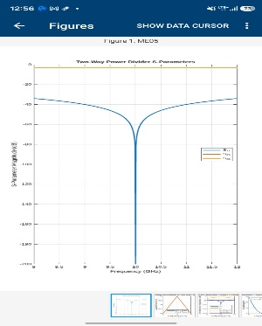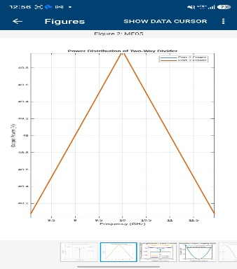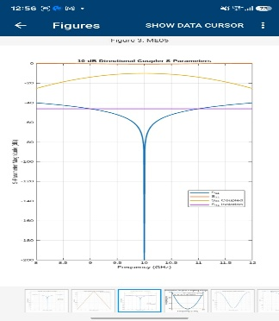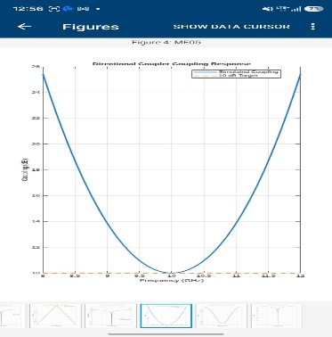
Result:
The microwave directional coupler and two-way power divider were simulated successfully. Their S-parameters were analyzed to evaluate return loss, insertion loss, coupling, isolation, and power division characteristics.

